Environmental Permit Request Instructions
Once the project is opened Select “General” on the Left hand side of the screen.
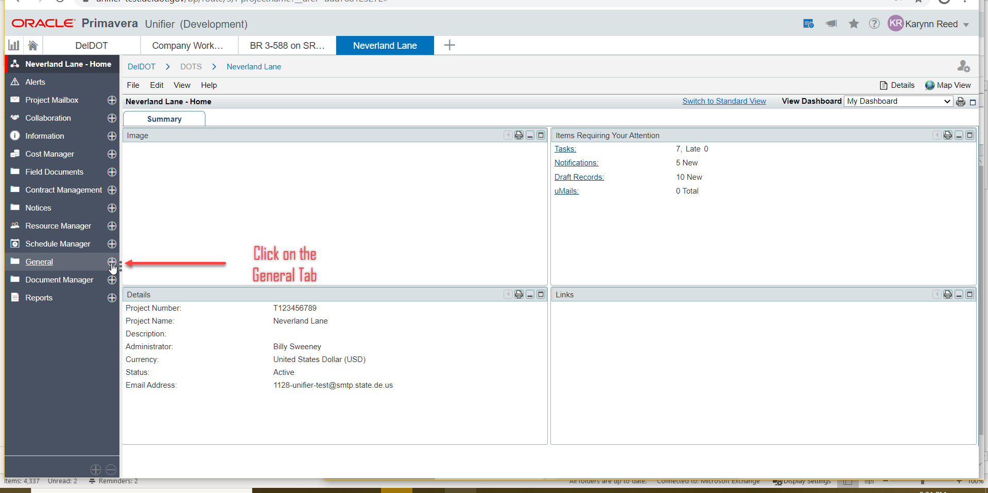
This will expand the Options under the General Tab. Select “Environmental Permit Request”
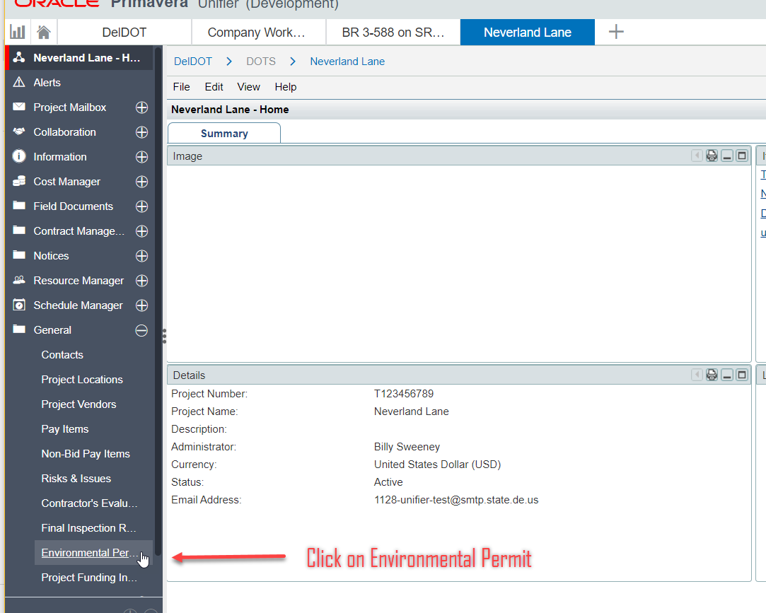
Once this has been selected the Permit Request Record page will open up. Click on “Create” to begin the Permit Request Form.
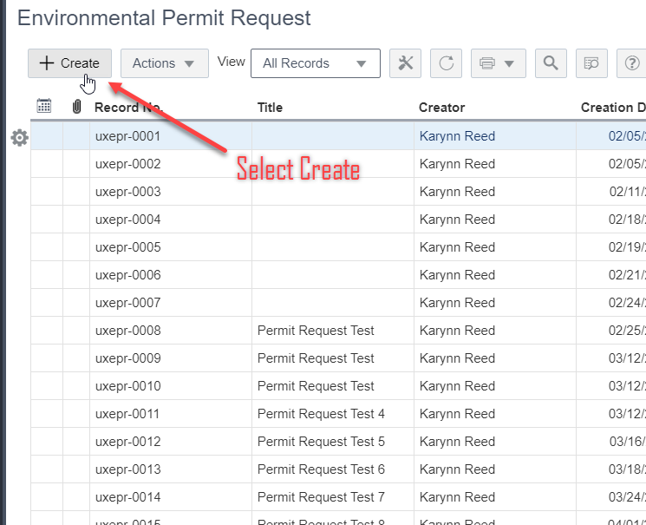
Once the Permit Request Form opens fill out the Editable Fields such as Title, Phone, Supervisor, Location, etc. The Creator, Creation Date, Record Number, and Status are automatically filled out once the Form is Submitted. When the Fields are filled out, click on Send in the Right-hand corner. This will open another window that allows you to Submit this Section.
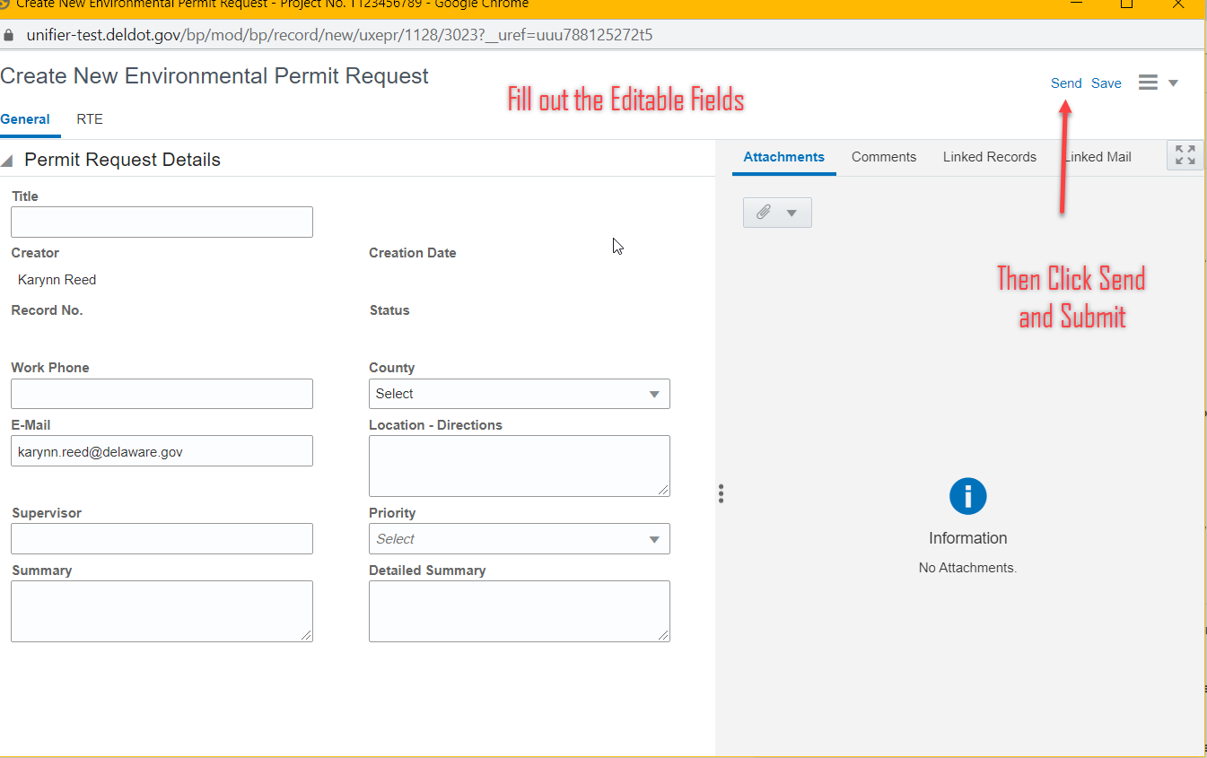
After that Section is Submitted the Record list will automatically open. Find the Record that says “ Submitted” and click on it.
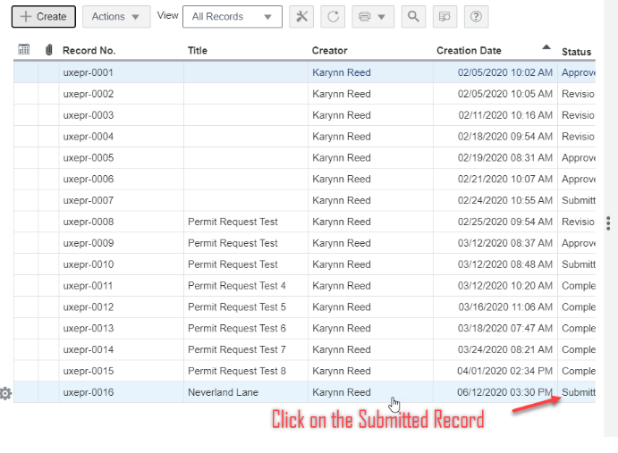
Once the record I selected “Accept” the task on the Right-Hand corner. This will then allow you to proceed to the next portion of the Permit Request Form.
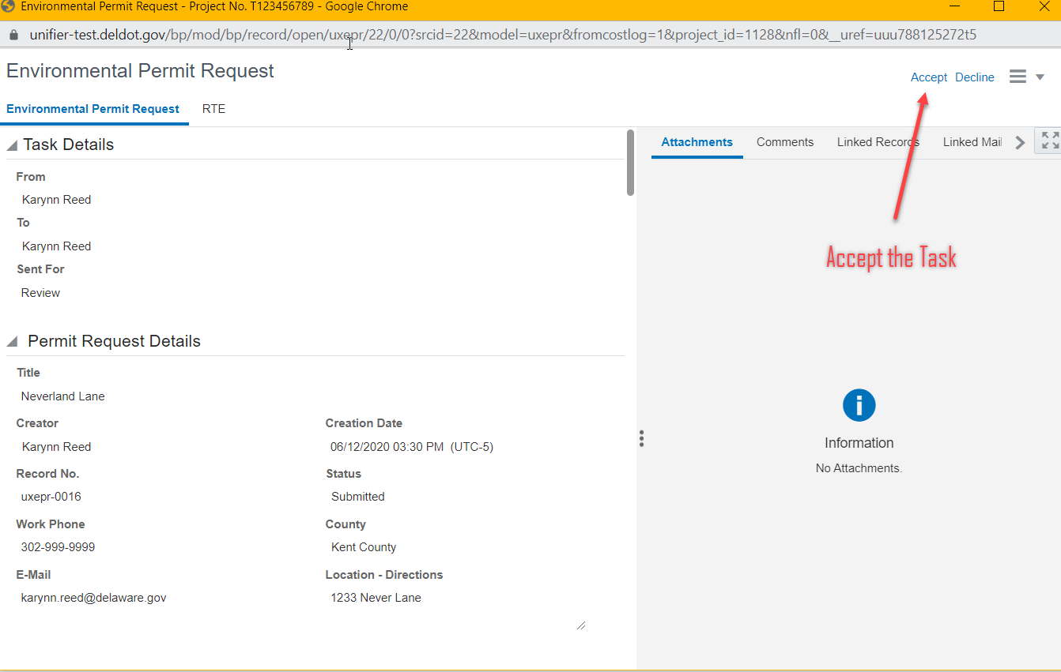
Note: the previous information is Editable from the Requestor. However you may fill out the proceeding information and Send the form back to the requestor for “Revisions”. The requestor will not be able to see the new information that is filled out in this step.
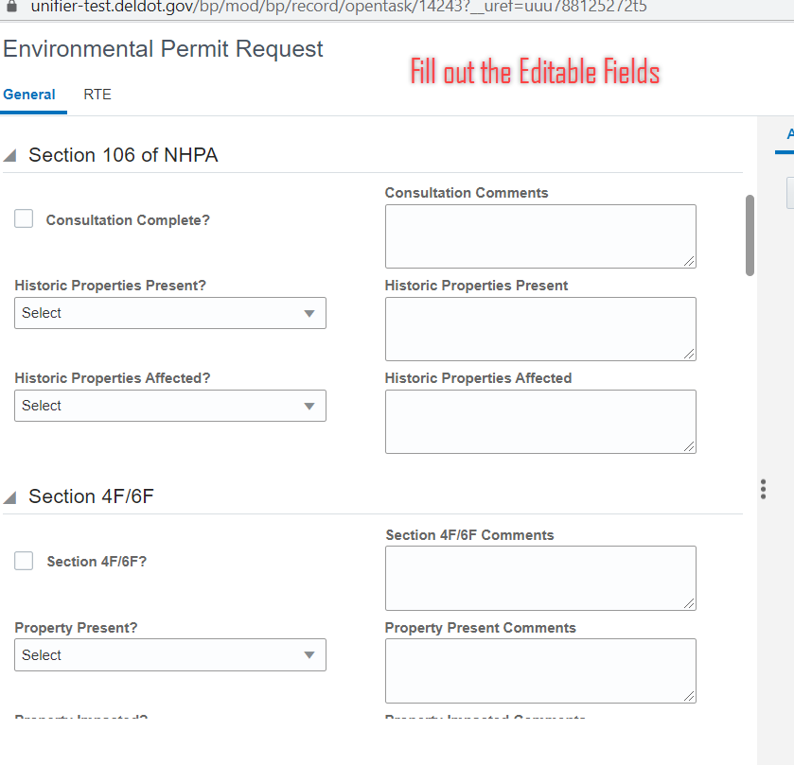
Next to the General Tab is the “RTE” tab. Select RTE and click on “Add” to open up the RTE portion of the form.
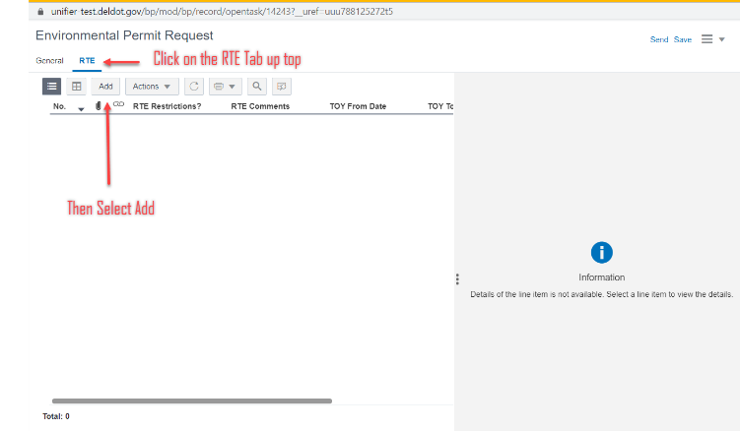
Fill out the Editable information and then click on either “Save” or if there are multiple Restrictions click on “Save and Add New”
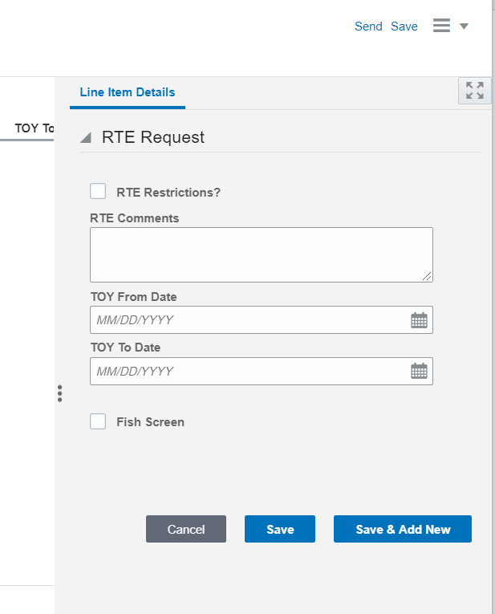
Once finished click on Send and then the following window appears. In this step, there is the “Request Revision” if the requestor needs to revise information originally provided or “Permit Issued” which issues the permit.
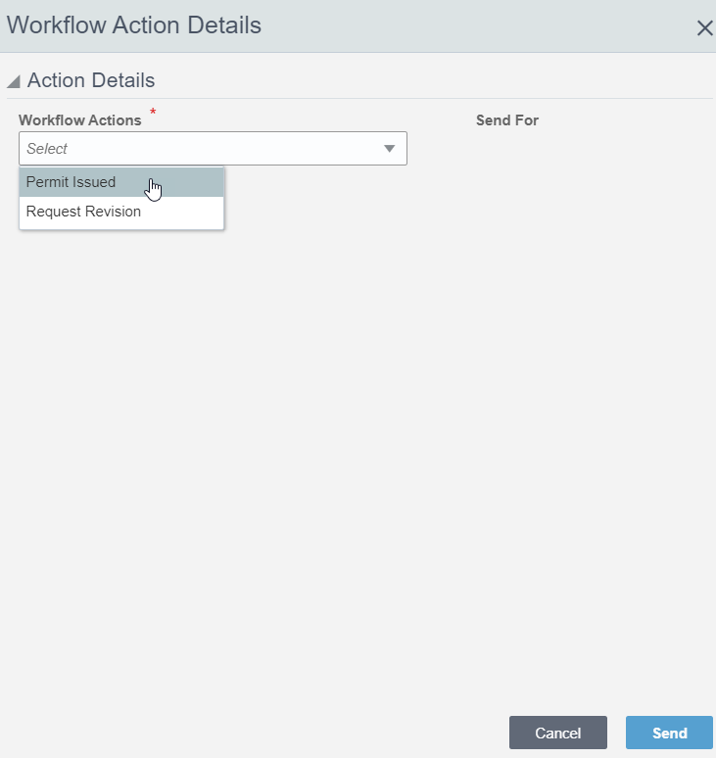
Once Submitted then the record page opens again. Under the status, it will now say “In_Construction” if the Permit was issued.
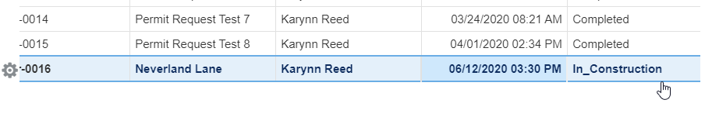
Click on the record and then all of the information will appear. Scroll all the way down and a new field labeled “Construction End Date” is there. Proceed to fill out the date and click “Send” once completed.

